|  |
| --- |
| Microsoft Corporation |
| TSL Power Tools |
| Routines for web and load testing with Visual Studio 2010 |

|  |
| --- |
| Microsoft Testing Services  12/27/2011 |

# Templates

## Testing File Templates

There are 6 different Visual Studio templates included with the toolset. These make it easy to create new plugins and rules in your test project. To use the templates, copy the zipped files to the VS templates folder (do NOT unzip the six files).

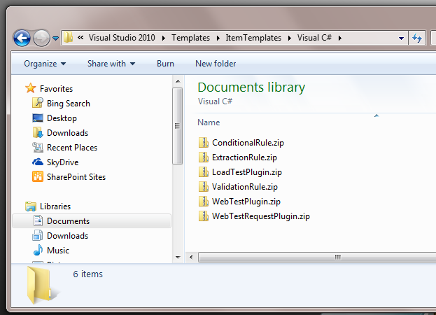

Once they are copied, you can use them any time you add a new item to your project:

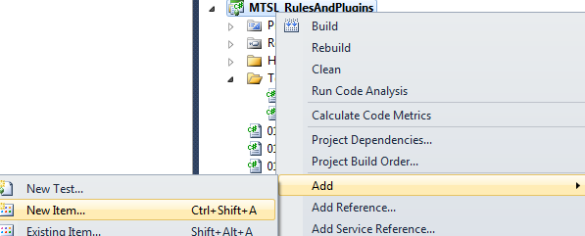

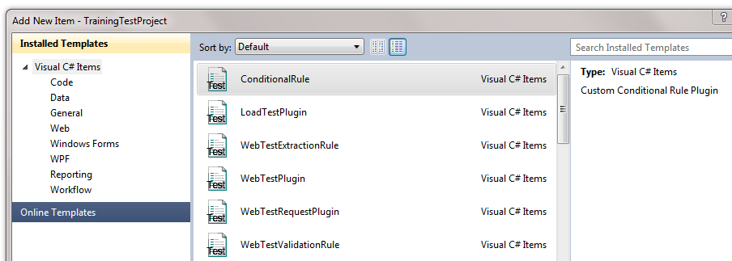

In many cases, the code will contain several areas that are commented out. Uncomment these as needed.

## Testing Project Templates

There is a new project template for Custom Data Collectors. Copy the zip file into the Visual C# foler of the ProjectTemplates folder. Leave the zip compressed.

To get access to this template, choose to Add a new project, highlight Visual C# and then choose DataCollectorProjectTemplate

